***What is romanticism***

Romanticism is the attitude or orientation that influenced many works of literature, painting, music, art, poetry, writing, criticism, historiography and many other forms of art that took place in western civilization over the period of late 18th to the mid-19th century. Romanticism demonstrates multiple characteristics such as; strong emotions, in awe of the natural world, the celebration of being yourself, the interests of the common man and the importance of childhood innocence.

**Philosopher**

One of the main pioneers of romanticism would be Jean-Jacques Rousseau. He is considered to be one of the fathers of romanticism. Through the use of his treatises and novels inspired the leaders of the French revolution and the whole generation of poets, writers, and artists.

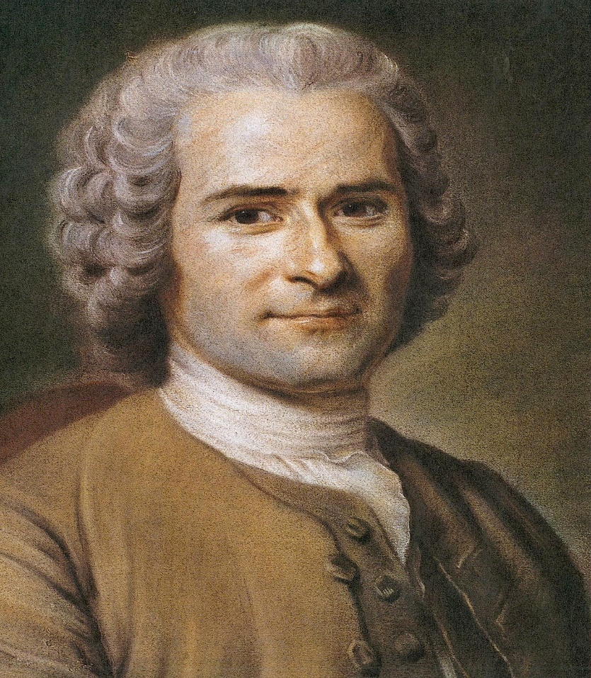

**Poet**

Percy Bysshe Shelley was a English poet that wrote many pieces that have focused on romanticism. Some of her works included :Ozymandias, Music, when soft voices die, Stanzas Written in Dejection, Near Naples. These pieces have a great use of romanticism

https://plato.stanford.edu/entries/rousseau